How to Prepare an Awesome Presentation in English

By [Marie-Anne Duffeler](https://blog.tjtaylor.net/author-marie-anne-duffeler/)

That was a great introduction your boss just delivered. The room is quiet and now it is your turn…your turn to speak.

Maybe you need to present your team, or deliver a sales pitch, or explain some figures and trends.

One thing is for sure: your presentation has to be awesome!

And your presentation will be in English, of course, as it is the language of communication at work.

Let’s think back: your English is quite decent – you can travel abroad and make yourself understood everywhere, you can communicate on the phone with your English-speaking colleagues and get the message across, and you write so many e-mails every day.

True, but these are familiar situations.

This time, however, you feel anxious because this presentation is formal and you have only one chance to get it right.

Speaking in public has always made you nervous, but speaking in public *in English* makes you twice as nervous.

What can you do? Simply follow this guide, which will help you step by step to prepare an awesome presentation in English.

First I will introduce the steps to create the oral presentation, and second we will look at some tips for the format and the style.

How to Prepare in 5 Steps

Remember that the stress before giving an oral presentation is normal, and even beneficial – it will give you the energy and motivation to prepare a good presentation, and preparation is key to delivering a memorable speech.

Good preparation will also give you confidence, which in turn will make speaking in front of your audience easier.

The five steps to follow to prepare a good presentation are simple to remember: they are the ‘**BASIS**‘ steps.

**B** = brainstorm  
**A** = audience  
**S** = slides  
**I** = ideas  
**S** = simulate

Let’s look at each step carefully.

1. Brainstorm

Brainstorming means **putting on paper all the ideas that are connected to the topic of your presentation**.

You can brainstorm alone or with colleagues. Ideally you should take a sheet of paper and write on it all the information you know and all the ideas you have about this topic.

A common way of brainstorming consists in writing the main topic inside a circle at the center of your page and then jotting down all around it the ideas and information connected to it. You can use arrows to indicate relationships.

Example of a mind map

2. Audience

Knowing who you will address is vital as it determines what information you need to select from your brainstorming session.

**Keep only the information that is important to your audience**.

If you add unnecessary information, you will end up losing your audience’s attention and your important message will get lost. So select carefully what to include in your presentation.

Another important reason to know your audience is the **degree of formality** that you need to use.

For example, how to address the listeners (“Ladies and Gentlemen” as opposed to “Hi everyone”), and whether or not to include humor (but I will come back to that later).

Make sure you find out who your audience will be before preparing your presentation.

3. Slides

**Visual aids are key**: they help you to remember what to say, and they help the audience to understand your presentation. However they need to be used wisely.

Most presentations will have slides, which can be designed with various software programs (e.g. PowerPoint, [Open Office Impress](https://www.openoffice.org/product/impress.html) or [Prezi](https://prezi.com/" \o "Visit the Prezi website" \t "_blank)).

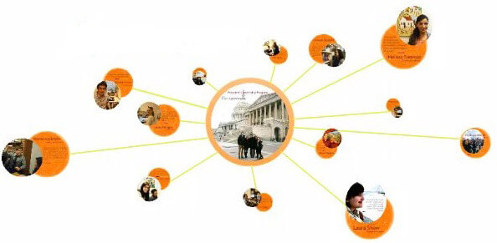Prezi can help you create a more visually interesting and dynamic presentation

Because your slides contain the information about your topic, you do not need to memorize your whole presentation, nor do you need to use clumsy paper notes, and so your hands can move freely during your speech.

When designing your slides remember:

* include an overview at the beginning of your slideshow
* present only the information that you have selected in step 2, only the information that is relevant to your audience
* present only one idea per slide
* write only keywords. Lengthy text will only detract your audience’s attention
* include numbers if necessary: long numbers are easier to grasp when they are written
* include as many pictures (or graphs) as possible – a picture is worth a thousand words.

4. Ideas

Now that you have designed your slides, you need to accompany them with explanations. This step is the most difficult one if English is not your native language.

You need to prepare the explanation for each slide. In order to describe the idea in each slide, you need to use precise vocabulary combined with correct grammar – and to deliver both fluently.

So, sit back and look at each slide, then say out loud (or do it mentally if that is not possible) what you will say in front of your audience.

**Describe each idea with your own words in the most natural fashion, as if you were explaining it to a friend or to a close colleague**.

If you do not know some terms, look them up in a dictionary and write them down.

However, resist the urge to write a script for each slide. Written speeches generally get in the way of effective communication as the speaker ends up reading a script instead of talking to the audience. Only talented speakers can make written speeches sound natural.

Also, rely on what you already know in English. Now is not the appropriate time to venture into grammatical constructions that make you feel uncomfortable. There are many ways to express ideas, so use the words and grammar that you know well.

5. Simulate

The final step is **simulating the actual presentation** and it is essential to the success of your presentation.

This is what you need to do:

* First, record your presentation with a video camera
* Watch the recording and assess it with a self-assessment grid (I’ve included an example below)
* Film yourself a second time while making the corrections you identified from the self-assessment
* Assess your performance a second time.

You can use a simple video camera, your smart phone, a digital camera or even a webcam.

However, it is important when you film yourself that the camera focuses on the upper part of your body, so that you can assess your body language.

Also, make sure you are standing up. This is important for 3 reasons:

First, because this will likely be your position during the real presentation.

Second, it is a position that opens up your lungs and helps you to breathe better (which is very important to speaking loudly and clearly).

Finally, it allows you to move and to accompany your speech with gestures that emphasize the meaning of your words – and so improves your communication.

How to Self-Assess and Improve your Presentation

After you have filmed yourself, watch your presentation with a critical eye – give yourself both positive and negative criticism.

What did you do well? What do you need to improve?

They are many aspects to oral communication besides the words you say – your voice, body and eyes need to complement your speech.

To evaluate your performance you can use the following self-assessment grid: